Task 4
4.3) The intent of the Strategy pattern is to define a family of algorithms, encapsulate each one into a separate class, and make them interchangeable. It lets the algorithm vary independently from the clients that use it. Whereas the intent of the State pattern is to allow an object to alter its behavior when its internal state changes, the object will appear to change its class.

Task 5

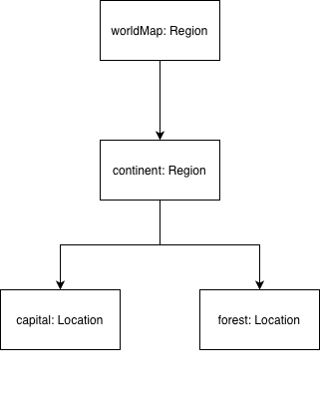

Task 6
